2/2023

v

**Screening-Level Dam Breach Inundation Study Tool**

For Dams with an Undetermined Hazard Classification User Guide & Technical Basis



Arthur Kay  
LEAD MAPPING & DATA MGMT

VA DEPT OF CONSERVATION

804-322-9420

ARTHUR.KAY@DCR.VIRGINIA.GOV

Contents

Executive Summary 3

Tool User Guide 4

Detailed Model Documentation 9

Summary of Required Software and Datasets 9

Methodology Overview: 10

Study Distance 10

Model Domain 10

Hydroconditioning: enforcing culverts 10

Digitizing Stream Centerline 11

Height Above Nearest Drainage 11

Hydraulic Properties Calculations 13

Manning n Values: Roughness Coefficient Calculations 15

Reach Rating Curves and Steady Flow Analysis 16

Dam Breach Discharges 16

Discharge Comparisons 16

Flood Extent Compared to Steady-Flow 1D & 2D HEC-RAS Models 17

Quality Assurance, Review and Limitations 17

Conclusion 18

Appendix 1 - Consequence Module Methodology: 18

There are key datasets and reference data used in this method including: 18

Consequence Module Overview 18

Building Footprint Data 18

Addressing and Structure Types 19

Depth Calculation 19

Structure Distance Referencing 19

Roadway Impacts 19

Roadway Depth Calculation Data Preparation 20

Roadway Depth Calculation 20

Road Distance Referencing 20

Cartographic Module Overview 21

Map Sheet Indexing 21

Panel Locator 22

Legend Overview 22

Call Outs 22

Appendix 3 – Virginia Hazard Classification Data 23

Appendix 5 – Development of more detailed methodologies for estimating PMF and PMF with Break Flows to be tested and incorporated into future simplified modeling enhancements 26

PMF Estimation (Dewberry, 2008) 26

Breach Average Width Formula 28

Peak Discharge Formula 29

29

Works Cited Bibliography 30

Other Refences 31

# Executive Summary

Objectives:

1. Rapid process for initial screening and provisional hazard classification assessment for unknown hazard dams
2. Provide provisional inundation maps, EAP / list of impacted roads and properties to EMS in emergency situations in cases where no data would otherwise be available
3. Receive federal funding credit for dams believed to be high hazard as a result of tier 1 screening

The purpose of this report is to document the approach DCR Dam Safety will take to determine the dam break inundation zone (DBIZ) impacts and hazard ratings for unknown dams in the Commonwealth of Virginia. The recommendation is to use a tiered study approach for DBIZ modeling and mapping in order to increase the development of DBIZ maps and associated EAPs where owners have not undertaken such studies. The premise of the tiered study approach is that having a simplified DBIZ and EAP is better than having no information, and will help steer limited funding for more detailed DBIZ studies to the highest priority dams in need of more detailed evaluations (FEMA, 2013).

Dams were prioritized to receive letters based on impounding capacity and a simplified screening methodology utilizing a 3-mile downstream assessment to identify potential structures in the floodplains and roadway crossings. This screening assessment methodology has a number of limitations that can be improved upon.

Reviewing FEMA Special Flood Hazard Areas (SFHAs) within a GIS application as a proxy for dam break inundation zones has limitations: many rural communities lack inundation maps due to the high cost of flood modeling, lower order streams and headwater areas are often not represented in the SFHA, accuracy issues due to data limitations of some of the legacy Flood Insurance Studies (this can lead to false positives), and lastly SFHAs do not account for dam failures and therefore are less conservative especially within the downstream vicinity of a dam.

We propose using the Simplified Inundation Mapping (SIM) model that resolves the limitations of our previous risk screening methodology. SIM meets the requirements to be a considered a simplified dam break inundation study because it represents the best data available. The model is an automated procedure that utilizes a seamless statewide LiDAR elevation data mosaic, estimates a conservative danger reach / study length, and applies the Height Above Nearest Drainage (HAND), a geomorphic algorithm to calculate flooding depths and extents. The model was tested and calibrated against 5 probable maximum flood with dam failure scenarios from detailed inundation studies. Subsequently a validation set of 25 detailed inundation studies was compared to the results of the SIM and had an average agreement relative to inundated area of 86.5% with the median agreement being 93.1%. The model was shown to be conservative in the vast majority of cases.

# Tool User Guide

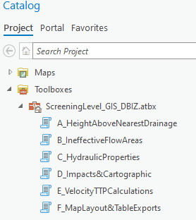

1. Using map template provided, navigate to “ScreeningLevel_GIS_DBIZ” toolbox in Catalog Pane
2. Ensure the dam points layer that will be used by the model is in GCS NAD 1983 (WKID 4269) and has the following field schema (only field names spelling matters, order does not)

|  |  |  |  |  |
| --- | --- | --- | --- | --- |
| TopA | Float |  | ToeEl | Float |
| NpA | Float |  | NpEl | Float |
| NpV | Float |  | TopEl | Float |
| SrchgV | Float |  | TopH | Float |
| MaxV | Float |  | NPH | Float |
|  |  |  | DA | Float |
| Name | Text |  | CN | Float |
| County | Text |  | PMP_06 | Float |

1. Run “A_HeightAboveNearestDrainage”
   1. Inputs:
      1. Dam Points Layer
      2. Inventory Number
      3. Root Folder – new folder will be created inside
      4. DEM - preferably a statewide LiDAR DEM
      5. Burn Length – user selected length to burn culverts into DEM
   2. Outputs:
      1. HAND based Depth Raster & Flood Extent feature classes
      2. Folder Structure Created:
         * {Root Folder}/
           + {123456}/

{123456}.gdb

scratch.gdb

1. 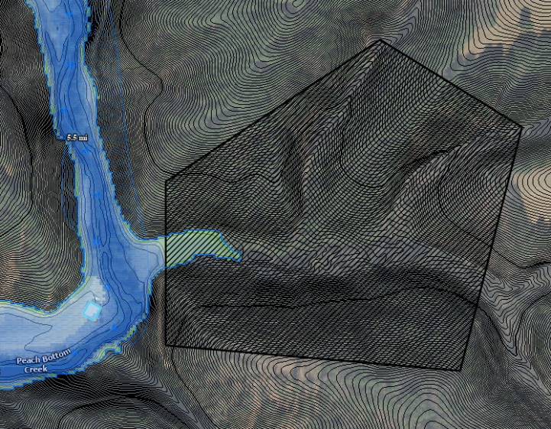Run “B_IneffectiveFlowAreas”
2. This tool creates a feature class named “VA{ID}_InefFPoly” and adds it to the map
3. Edit this polygon to draw all ineffective flow areas. Any areas marked will not be treated as conveyance for purposes of calculating hydraulic properties. Flooding extents will still be drawn in areas marked as ineffective flow.

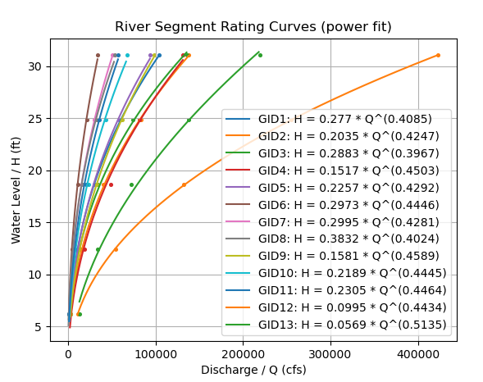

1. Run “C_HydraulicProperties”
   1. Outputs: {12356}_RatingCurves.png automatically saved into project folder
   2. Final Flood Extent and Depth Raster feature classes

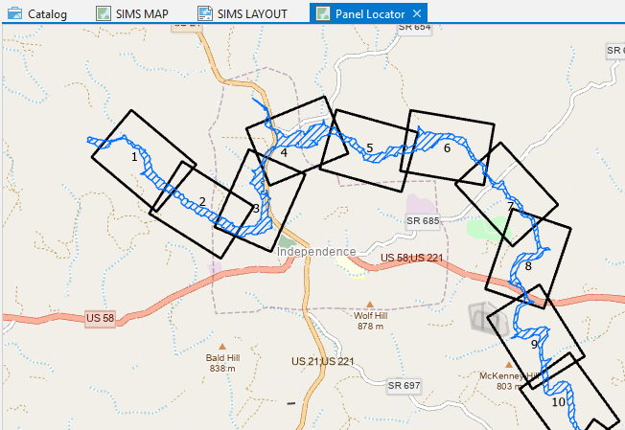

1. Run “D_Impacts&Cartographic”
   1. Outputs:
      1. Mapping Grid Index
      2. Adds Grid Index and Flood Extent to “Panel Locator” Map
      3. Structure Impacts
      4. Road Impacts
      5. Stream Linear Referencing feature class / length markers
      6. Dam Point for final map cartography
   2. Adjust symbology as needed on Grid Index layer
2. Configure Map Series
   1. Navigate to “SIMS LAYOUT” layout template
   2. Right click and view SIMS LAYOUT properties
   3. Enable Map Series based on GridIndex layer and set rotation to angle field

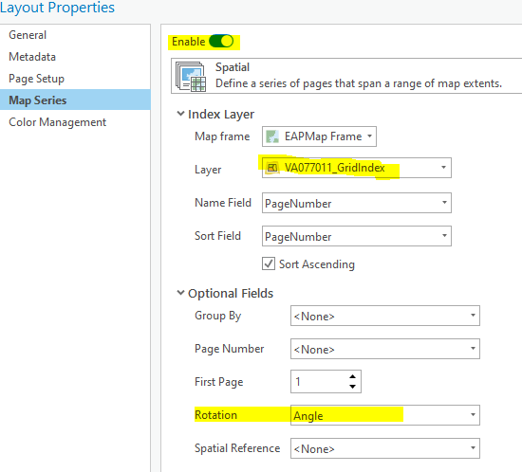

1. Run “E_VelocityTTPCalculations”
   1. Outputs:
      1. {123456}_vel.png – reach average velocity curve fit
      2. VA{123456}_RoadCallout
   2. TTP has been calculated for roads and structures and predefined callouts will now display
   3. Review, assess and make adjustments to output as needed against DEM, VGIN satellite imagery, bridges & culverts data, etc. 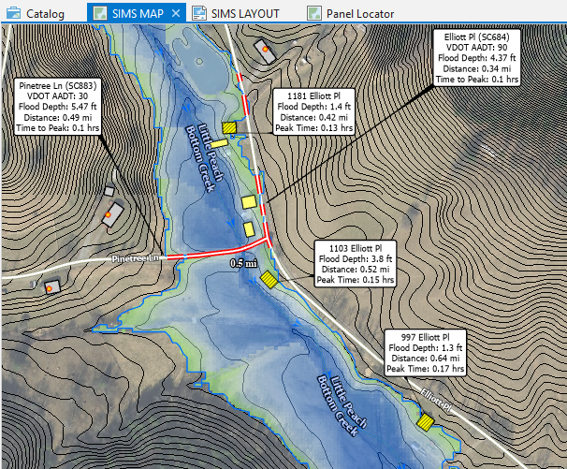

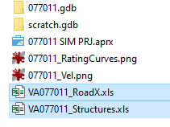

1. Run “F_MapLayout&TableExport”
   1. Outputs:
      1. Updates Layout surround text including dam name, id number, county and max depth label
      2. Exports VA{123456}_RoadX.xls and VA{123456}_Structures.xls to be included in Appendix A Impacts Summary of report
2. Prepare report using Mail Merge Template and ensure file paths in defined mail merge spreadsheet line up with existing folder structure. Use F9 and Alt+F9 to toggle mail merge fields and refresh to update chart inserts

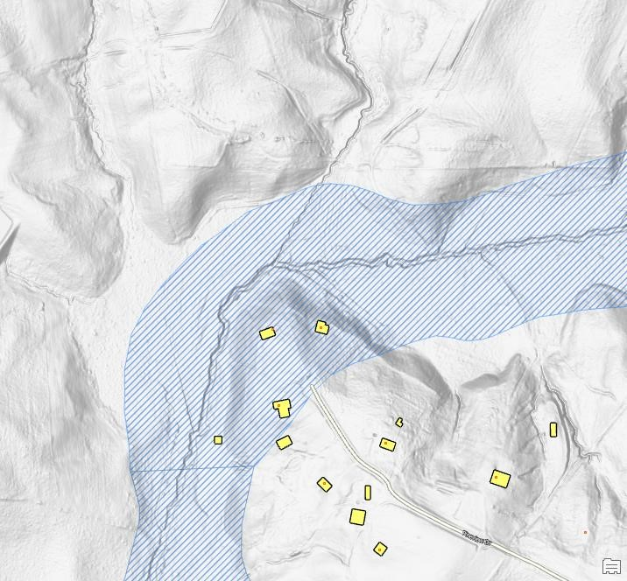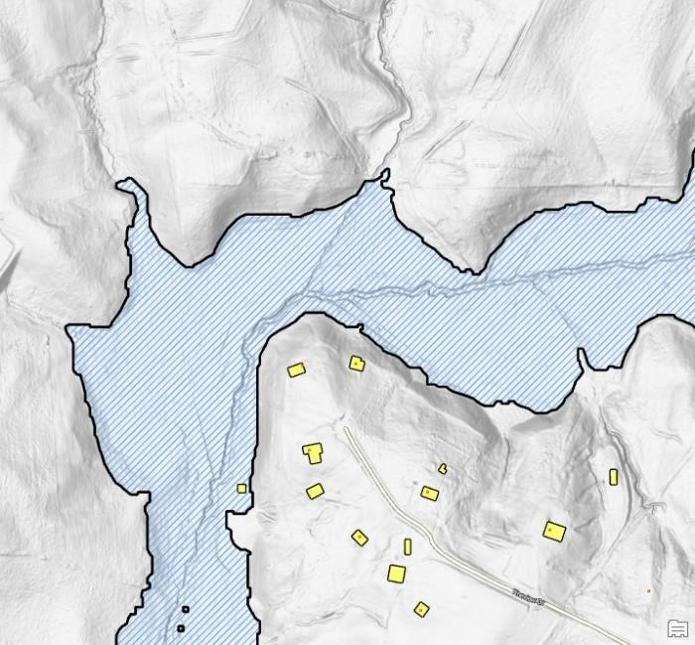

*Figure*

*1*

*FEMA Floodplain showing nonconformance with LiDAR data*

*Figure 2 Result of the simplified*

*inundation mapping*

*methodology*

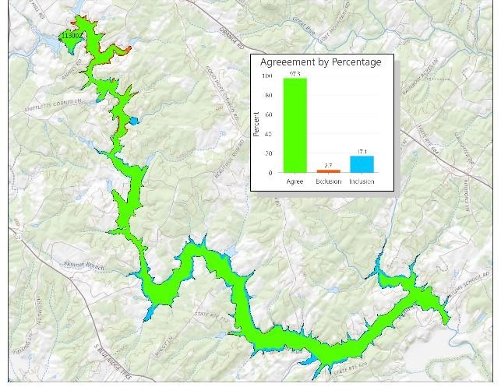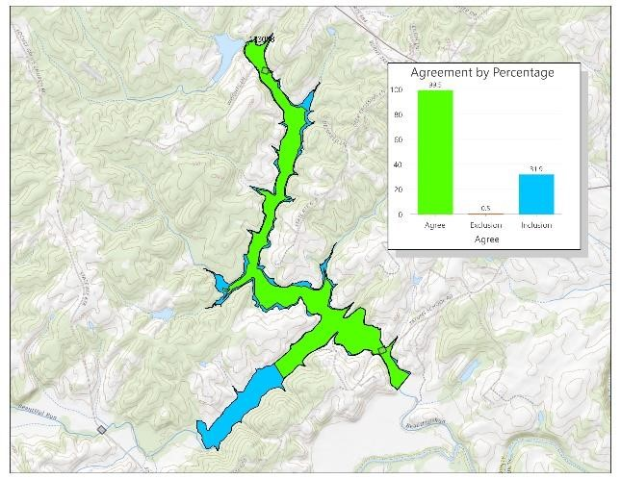

Fig 3. Two area comparison maps; green areas are agreement between the simplified and detailed models, blue areas are SIM overpredictions and red are areas are SIM underpredictions

# Detailed Model Documentation

## Summary of Required Software and Datasets

**Software Required:**

* ArcGIS Pro
* ArcHydro Extension

**SIM Input Datasets:**

* Seamless Statewide Lidar DEM Mosaic Dataset
* National Hydrography Dataset (NHDPlus High Resolution)
* DCR Dam Points
* Chesapeake Bay 1-Meter Land Cover dataset (VGIN)

**Impacts Model Input Datasets:**

* VGIN Address Points
* MSFT Building Footprints
* VGIN Roads Dataset
* VDOT Culvert and Bridges Dataset

**Required User Setup / Data Input:**

A minimal amount of user setup or input is required by the SIM model. Data attributed within the dam points layer will automatically be referenced by the model, primarily the dam inventory number, location, top height and top capacity.

Prior to running the model, technical basic data such as the top height and top capacity can be verified using LiDAR measurements, or if it has already has updated, this data will be reflected in the dam points attributes.

The modeler should move the dam point to the dam toe to designate the starting point and initial minimum elevation.

Lastly the modeler can provide a list of dam inventory numbers to run as a batch, a single inventory number, or the same but as a subset dam point feature class.

A more detailed approach is possible to build upon this methodology, but discussion on those will be mostly reserved until the more detailed methodology has been validated. The simplified method presented has already been tested and validated as a conservative approach.

# Methodology Overview:

## Study Distance

An empirical formula to predict inundation study length was constructed by measuring 234 inundation study lengths across the state, designating their dam height and volume as covariates, and performing a multiple regression analysis. The resulting formula is as follows:

𝐷𝑖𝑠𝑡𝑎𝑛𝑐𝑒 (𝑚𝑖) = 0.2818𝐻 + 0.0007𝑉 − 1.06

|  |  |  |
| --- | --- | --- |
| 1  2 3 4 5 6 7 8 9  10  11 12 13 14 15 16 17 18 19 20 21 22 23 24 25 >25 | |  | | --- | | TR-66 (NRCS 1985) method mentions breaches from small size class dams usually have an impact limited to 5-miles per less, which is seen from DCR’s dataset as the ~50% mark on this distribution chart | |

The nearest National Hydrography Dataset (NHD) flowline is traced downstream the distance as predicted by the empirical formula. A bounding box of the flowline with 1-mile buffer margins is generated and acts to constrain the model extent, becoming the model domain. 1-mile buffer margin was found to be sufficiently conservative to never exclude any potential flood / storage areas off stream but also not too large to slow down the model significantly. Further the regression equation incorporates a confidence interval factor, typically resulting in predicted study lengths that are equal to or greater than the observed study length.

## Model Domain

LiDAR projects were sourced from USGS 3DEP 1M, Original Project Resolution, and VGIN 2.5 ft sources. Projects met FEMA’s highest specification level (FEMA, 2010): bare earth, Quality Level 1 (USGS Specification), and hydroconditioned (bridges removed). DEM tiles were incorporated into a seamless statewide derived mosaic dataset with a consistent vertical units, datum, and coordinate reference system. This mosaic dataset is resampled and imported into the model with a processing extent equal to the model domain. While the resampling factor is adjustable, utilizing a 10 ft grid cell size runs quickly without sacrificing much precision (allowing truthful 3 ft contour lines).

## Hydroconditioning: enforcing culverts

Although most bridges have already been removed as part of the LiDAR provider’s contract with USGS/VGIN, the DEM is further hydroconditioned to enforce culverts. This process utilizes VDOT roads data and the NHD flowlines to sample elevations on either side of a roadway and creating a flow path through the roadway to allow for correct flow routing. The DEM then has all sinks filled and a D8 Flow Direction raster is created.

## Digitizing Stream Centerline

The NHD flowpath was created by USGS using a coarser grid (primarily 1/3 arc second – 10m) DEM. This flowpath is useful for downstream tracing to set the model domain and to assist with hydroconditioning, but would only be able to make an accurate HAND if its original 10m DEM is utilized. This model uses high quality LiDAR data and therefor a new streamline is creating using ArcHydro’s Flow Path Trace tool with the dam point as the starting point and the D8 Flow Direction raster as input. This way the new flow path will be in agreement with the model’s DEM and will become the valley thalwag, or reach drainage line.

## Height Above Nearest Drainage

Height Above Nearest Drainage (HAND) is defined as the height of each grid cell with respect to the nearest stream cell it drains to, thus indicating the water height at which the cell would be inundated. A HAND raster essentially removes channel slope (all pixels along the channel represent a height of 0), which allows various flood depth contour slices or flood extents to be rapidly determined by simple raster algebra:

𝐷𝑧 = 𝐻𝑤𝑎𝑡𝑒𝑟 − 𝐻ℎ𝑎𝑛𝑑

Where:

𝐷

𝑧

grid cell flood depth

=

𝐻

𝑤𝑎𝑡𝑒𝑟

reach maximum water depth

=

𝐻

ℎ

𝑎𝑛𝑑

=

grid cell relative height

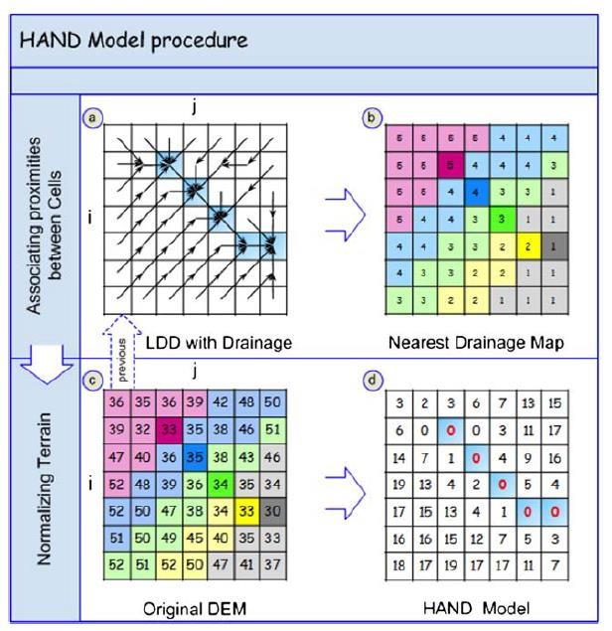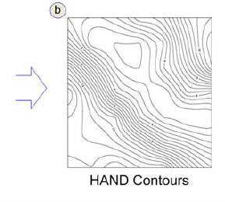

*Figure*

*2*

*HAND*

*raster algorithm*

*step*

*.*

*a) local drain direction, b) nearest drainage map, c) original*

*DEM, d) HAND model, e) Hand contours*

*. Source: Nobre, et al 2015*



e

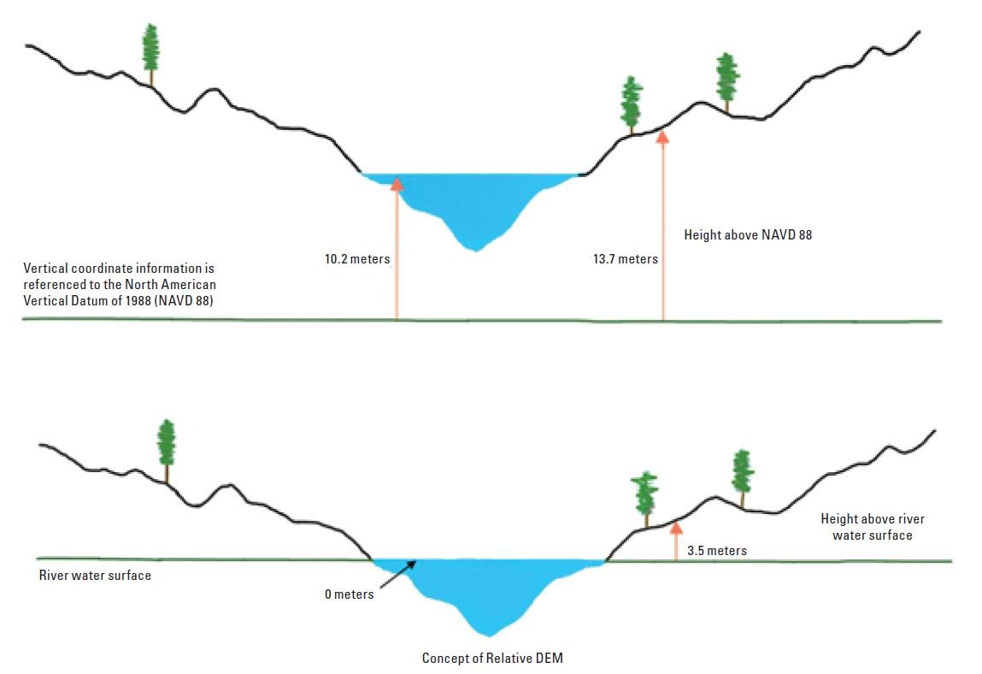

*Figure 3. Conceptual depiction of HAND. Source: A GIS tool for cost-effective delineation of flood-prone areas (USGS 2013)*

This predefined HAND raster can be used to assist in rapid stream forecasting (Oak Ridge National Laboratory Continental Flood Inundation Mapping, & National Flood Interoperability Experiment). Another application is for emergency flood response with the Pin2Flood field application, allowing first responders the ability to make their own flood maps based on live flooding conditions (University of Texas at Austin Center for Water & the Environment). The applicability of HAND to fluvial inundation mapping has been demonstrated in several studies (Rodda, 2005, Nobre et al, 2016).

**Simplified Approach for a Conservative Flood Extent**

All that is required to assess a maximum flood depth ($H_{flood}$) is the LiDAR based stream centerline and HAND raster. The proposed equation for maximum flood depth is:

$$H_{flood}=H_{dam}*K_{h}$$

*Where:*

$$H_{flood}=Maximum Flood Height$$

$$H_{dam}=Dam Top Height$$

$$K_{h}=Scaling Coefficient/ H-Factor$$

NWS recommends for the maximum initial $K_{h}$ = 0.5 . Then $K_{h}$ is reduced every ½ to 1 mile downstream following a linear or curvilinear function to a minimum of 0.25 at 10 miles downstream and beyond. This approach was adopted in simplified methods utilized by South Carolina DHEC and North Carolina DEQ (Appendix 3)

In testing, the simulated attenuation by reducing the $K_{h}$ lead to underprediction of flood extents caused by the PMF with breach scenario, although it may conservative for modeling Sunny Day Failures, this was not tested.

Therefore, in our proposed simplified model the equation is:

$$H_{flood}={0.6 *H}_{dam}$$

This has a 10% factor of conservation in terms of flood depth. By removing the scaling coefficient’s attenuation over distance this will create a conservative flood extent that should never be surpassed in the majority of cases. This can make it an ideal tool for rapidly screening our inventory of unknown dams since the level of confidence, particularly if there are no downstream impacts would be heigh.  
  
If structures or roadways are found to be downstream, then a more detailed approach may be warranted.  
  
**Wrap up of SIM Methodology**  
At this point a simplified inundation extent and depth raster is output and the dam can be mapped and impacts assessed through the cartographic module (Appendix 2).   
  
While the model can be run as a batch process, the primary pre-requisite is that the technical basics (mainly dam height) is accurate. This batch approach may be beneficial for performing region wide analysis and filling data-gaps until more detailed approach is available.

Whether or not the SIM model is run on individual dams or in batches, the results will be individually reviewed and scrutinized before any report, preliminary hazard determination, or EAP would be made.

Calculating reach-average hydraulic properties from this model allows application of manning’s equation in order to check observed discharge against empirical formulas.

Hydraulic Properties CalculationsThe following equations are provided in general form from (Zheng & Tarboton, 2018). These are applied at any cell $(c)$ in the inundation zone $Iz$ at depth $(y)$.

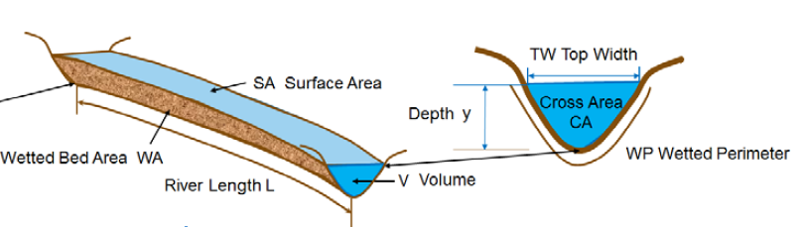

Cell Area $A(c)$*:*

$$A(c)=dx ^{*}dy$$

Surface Area $S(y)$:

$$S(y)=\sum{A(c)}$$

Volume $V(y)$:

$$V(y)=\sum{A\left(c\right)*}d(c,y)$$

$$Where, \\ d\left(c,y\right)=depth at a cell$$

Bed Area $B(y)$:

$$B(y)=\sum{A\left(c\right)*}\sqrt{\left(1+slp⁡(c)^{2}\right)}$$

$$Where, \\ slp\left(c\right)=surface slope of cell \left(c\right) expressed as rise over run$$

Reach-average channel width $W\left(y\right):$

$$W(y)=S(y)/L$$

$$Where, \\ L=reach length$$

Cross Section Area $A(y)$:

$$A(y)=V(y)/L$$

Wetted Perimeter $P(y)$:

$$P(y)=B(y)/L$$

Hydraulic radius $R(y)$:

$$R(y)=A(y)/P(y)$$

Many of these calculations can be implemented through Zonal Statics SUM on the raster of interest (e.g. depth or slope), then performing field calculations (e.g. multiply total depth sum by cell area to find volume).

Lastly once the hydraulic property table has been calculated, the associated discharge $Q\left(y\right)$ of flood depth $\left(y\right)$ can be evaluated with the following equation.

$$Q(y)=\left(\frac{1.49}{n}\right)AR^{\frac{2}{3}}S^{\frac{1}{2}}$$

$$Where, \\ n=Manning^{'}s Value \\ A=cross-sectional area \\ R=Hydraulic radius \\ S=Channel Slope$$

Manning’s n Value can be assigned as a static value or it can be calculated through the below methods.

## Manning n Values: Roughness Coefficient Calculations

Appropriate Manning’s n Value tables can determine through referencing HEC-RAS manual and other resources such as Chow, 1959.  
The following table presents an approach to calculate a composite Manning’s n through the Chesapeake Bay 1-meter Land Cover Dataset. The dataset provides state-wide coverage from a 2016 study conducted by a partnership between VGIN and the Chesapeake Bay Conservancy. This provides significantly finer spatial resolution than the National Land Cover Dataset (NLCD) which is a 30-meter resolution. Additionally Building Footprints were converted to raster with the highest roughness value available in 8-bit (2.54) and overlayed on top of the original LC dataset.   
The landcover dataset is clipped to the estimated flood extent, then the LC class codes are reclassified to Manning’s n Values (through 8-bit conversions). Zonal statistics are then calculated on this Manning’s n raster which provide area weighted average Manning’s n values and the resulting values can be converted back to float values in tabular format.

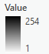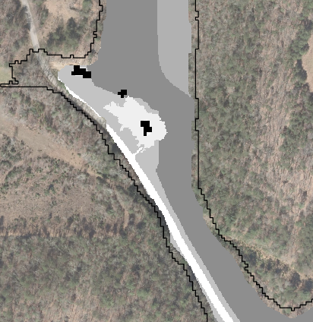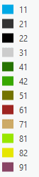 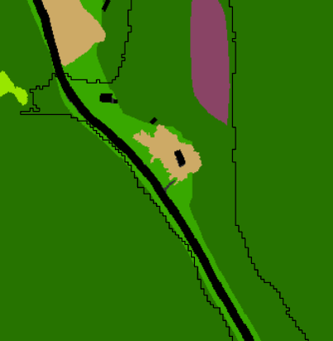

Figure 8 Left - Original Chesapeake Bay 1-m LC classes. Right - Reclassified to 8-bit manning's N values

|  |  |  |  |  |
| --- | --- | --- | --- | --- |
| **Chesapeake Bay 1-Meter Land Cover** | | | | |
| Code | Type | Mannings N | Rounded | unsigned 8-bit |
| 11 | Water | 0.04 | 0.04 | 4 |
| 21 | Impervious (spectral) | 0.0145 | 0.01 | 1 |
| 22 | Impervious (datasets) | 0.0145 | 0.01 | 1 |
| 31 | Barren | 0.0265 | 0.03 | 3 |
| 41 | Forest | 0.135 | 0.14 | 14 |
| 42 | Tree | 0.08 | 0.08 | 8 |
| 51 | Scrub/Shrub | 0.115 | 0.12 | 12 |
| 61 | Harvested/Disturbed | 0.04 | 0.04 | 4 |
| 71 | TurfGrass | 0.03 | 0.03 | 3 |
| 81 | Pasture | 0.0375 | 0.04 | 4 |
| 82 | Cropland | 0.035 | 0.04 | 4 |
| 91 | Woody Wetlands | 0.0975 | 0.1 | 10 |
| 92 | Emergent Wetlands | 0.0675 | 0.07 | 7 |
| 254 | Structures (dataset) | 10 | 2.54 | 254 |

## Reach Rating Curves and Steady Flow Analysis

Reach stage-discharge curves can be calculated from the reach-average hydraulic properties and incorporation of roughness coefficient (Scriven et. al, 2021).

A reach-average stage-discharge rating curve will be assessed and the maximum discharge for the height evaluated will be determined and checked against empirical methods.  
A more detailed methodology that accounts for changing downstream geometry (as well as potentially roughness, and channel slopes) would evenly segment the reach and calculate separate rating curves for each reach section. This would allow for an implementation of the continuity equation Q = V*A that accounts for varied conditions rather than composite reach-averaged conditions.

|  |  |
| --- | --- |
| Figure 9. Left - A single reach-average stage-discharge rating curve or Right - a family of reach-segment rating curves can be calculated using this methodology. |  |

## Dam Breach Discharges

The model utilizes the top height of the dam to evaluate a flood depth downstream as seen in SCDHEC’s SIM methodology this is reasonable as several empirical methods utilize dam height to estimate breach peak flow including SCS (1981), Kirkpatrick (1977), and USBR (1982). After the reach average hydraulic properties have been calculated at the defined stage, the stage can be equated to a peak discharge based on Manning’s equation for open-channel steady-flow. The SIM model observed discharge can be compared to empirical estimating of dam peak breach to ensure it is a conservative answer.

## Discharge Comparisons

The observed SIM discharge is compared to empirical peak discharge estimation methods such as Froelich 1995 or the Myers envelope PMF equation (Jarvis, 1942). This is demonstrated below for 141033 – Epperson Dam (Top Height: 31 ft, Top Capacity: 149 ac ft, Drainage Area: 1.24 sq mi). The observed SIM discharge was approximately 45,000 cfs, falling close to the

48,500 cfs estimate from the MacDonald 1984 envelope equation and significantly above the 12,000 cfs estimate from the Froehlich 1995 best fit equation.

0

10,000

20,000

30,000

40,000

50,000

60,000

MacDonald (1984

envelope)

SIM Observed

Value

Costa (1985)

MacDonald (1984

best fit)

Froehlich (1995)

**Dam Break Peak Discharge Estimate Comparison**

## Flood Extent Compared to Steady-Flow 1D & 2D HEC-RAS Models

The observed SIM discharge was utilized as inflow for both a HEC-RAS 1D steady flow model and a 2D steady-flow model (although HEC-RAS 2D models use unsteady flow equations, they can be modeled to simulate steady flow conditions). The results of this test showed that the hydraulic parameters and discharge estimated are accurate as it showed similar results to the two HEC-RAS models, although area comparisons have not been completed at this time they would likely be close to the in the 90% agreement range from visual from inspection.

|  |  |  |
| --- | --- | --- |
|  | |  | | --- | | View of bridge crossing in HEC-RAS: yellow line is SIM extent, blue depth raster is output from the “steady flow” simplified HEC-RAS 2D model with the discharge calculated from the SIM model as input | |

## Quality Assurance, Review and Limitations

The methodology will be reviewed with the Regional Engineering team and DCR dam safety management. Each simplified report would be reviewed and sealed by a DCR Virginia Licensed Dam Safety Engineer. A disclaimer will clearly explain that the report is the result of simplified mapping of the unknown dam portfolio for preliminary purposes and does not relieve the owner of regulatory obligation nor should these maps be used for design modifications to any dam.

## Conclusion

DCR has adopted a proven methodology for evaluating a large portfolio of unknown dams to make preliminary estimates of the impacts from dam breaks occurring when a dam is filled to the crest. The simplified method while not replacing the methodology required in DCR’s *Dam Break Inundation Zone Modeling and Mapping Procedures*, it provides the most reasonable estimate of impacts until such time the owner submits the full DBIZ study.

# Appendix 1 - Consequence Module Methodology:

**Consequence Input Datasets:**

## There are key datasets and reference data used in this method including:

SIM Output Datasets:

* Flood Extent Polygon
* Flood Depth Raster

Consequence Reference Data:

* VGIN/VDOT Roads and Railroad data
* VGIN Address Points
* VGIN Building Footprints & Microsoft Building Footprints (merged/dissolved)

## Consequence Module Overview

Once the SIM model runs a consequence assessment can be made using the output data as well as the above consequence input datasets. The results of this analysis should be scrutinized and will be discussed in the review portion of this methodology memo. Reviewing the results is streamlined because all symbology and labeling is applied prior to review.

## Building Footprint Data

VGIN’s Building Footprint layer is combined with Microsoft Building Footprints (MSFT BF) 2018 Data. VGIN Building Footprints are submitted quarterly by county tax GIS offices through GIS staff’s manual digitization or automated methods, while Microsoft Building Footprints were created using a feature detection Deep Neural Network algorithm on satellite imagery. By combining both into a seamless dataset, the benefits of both datasets can be realized and omissions from one dataset are often covered by the other. For example, agricultural structures may not be tracked by a county tax GIS office but are often times large and therefor

consistently and accurately identified by MSFT BF. Newer developments will not be reflected in MSFT BF layer but are present in the quarterly updated VGIN BF layer. Additionally, smaller structures like single car garages and sheds may not have been identified by MSFT BFs layer but many county tax GIS offices track them, so if secondary structures are of importance for economic consequence analysis more detailed secondary structure data can be reported on.

## Addressing and Structure Types

The merged Building Footprints layer is addressed through a 15 ft radius spatial join with VGIN Address Points data. Generally, structures that do not have associated address points are garages or agricultural structures. Structures with single address points are primary residences. Secondary structures with no address point can be still be addressed based on their nearest address. Structures with many address points typically represent apartments or commercial buildings. These structure types can be added via simple attribute field calculations based on the address point join counts. Additionally, structure size descriptions can be easily calculated based on the feature polygon area (e.g. small, medium, large, massive). Alternatively, simply creating a square footage attribute rounding polygon area to the nearest 100 ft creates an easy to review metric of structure size. Lastly searching the address for indicators such as APT (apartment), Unit (commercial), or LOT (mobile home) is an additional way to bring more descriptive structure types into the building footprints attributes layer. This methodology allows identification of structure types even though VGIN does not provide consistent statewide building type or zoning attribute due to numerous varied county schemas and potential schema changes.

## Depth Calculation

Flood depths at each building can be calculated through ArcGIS’s Zonal Statistics as Table geoprocessing tool, where structure OID is the zone id and the depth raster is sampled, raster sampling can be done as a mean, percentile, maximum or minimum. Mean depth is recommended since it will be the most representative of potential flood risk. The resulting statistics table is then joined by OID back to the structures layer; this results in an average depth and flooded area data (area to the nearest grid cell size e.g. 100sf). This process is extremely fast and relatively simple.

## Structure Distance Referencing

Rather than calculating a simple distance from the dam point, it is recommended to calculate the nearest distance along the stream centerline. This is accomplished by a process that converts the stream line into a linear referencing route layer. Then structures are located along the stream line “route” providing a distance along route AND a distance from the route. This is more accurate and specific than simple linear distance from dam point calculation since it takes into account stream meandering and will provide data more useful to Emergency Planning such as sorting structures by distance from dam.

## Roadway Impacts

The process to determine flood depths over roadways is similar to the structure depths process. There are some variations due to roadways with bridges removed from the DEM and the linear nature of roadways.

## Roadway Depth Calculation Data Preparation

Bridges are erased from the VDOT roads data utilizing the VDOT linear referencing system to identify bridge locations and lengths. This is because including the flood depth at the bridge

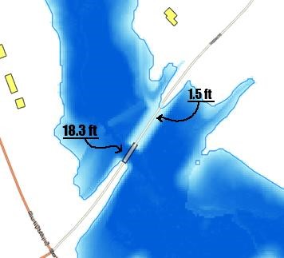

*Figure 4. Demonstrates removal of bridge from VDOT road data for more*

*accurate road overtopping depths*

|  |
| --- |
| The depth at the bridge is 18.3 feet, but since the bridge was removed from the road impact analysis, the true depth of the road deck is shown to be ~1.5 feet. |

crossing would greatly exaggerate an analysis seeking to determine flood depth over the roadway. This is depicted in the following figure:

## Roadway Depth Calculation

The roadway depths can then be calculated in a similar fashion as the structures. Rather than an average depth which is more representative of risk to a structure, the 90-percentile depth is used to define depth over the roadway. Since roadways can be long and significant changes in elevation, this evaluates the low point of the roadway that would pose the greatest risk. The 90 percentile is thought to be sufficiently conservative.

## Road Distance Referencing

Road distance from the dam is calculated in the same way as structures, except by considering the centroid of the roadway since referencing point data along the streamline allows for a single average distance. For roadways that are perpendicular to flow there would be no difference between referencing the complete line versus its centroid point. For road ways that are parallel to the streamline, the average distance based on the road centroid is calculated, rather than multiple distances representing a length along the stream line.

**Structure Impact Summary Table:**

The resulting feature classes can be export as excel tables and subset to the relevant attributes desired for the report. For structure impacts the data would typically be: structure type, full address, flood depth, footprint area, distance from dam, distance from stream center and centroid latitude and longitude.

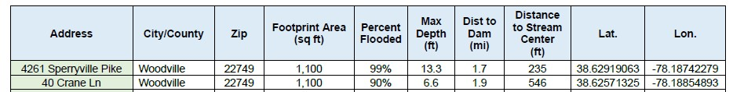

**Roadway Impact Summary Table:**

For structure impacts the data would typically be: street name, route name, flood depth, flooded length, distance from dam, distance to stream center, if there is a culvert or bridge structure, the structure’s VDOT inspection condition, and the structures width. Additional information could include VDOT district, residency and county, which could be useful information particularly if the impacted area spans multiple VDOT residences or districts. Additionally wave arrival times at key roads and structures would be computed using the relationship between travel distance and average velocity. Because the model is steady-flow only a single time can be computed.

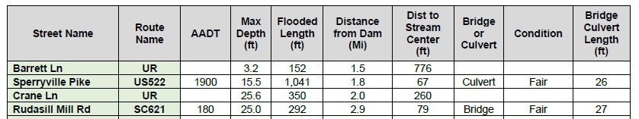

# Appendix 2 - Cartographic Module

## Cartographic Module Overview

The cartographic module turns the simplified inundation study and impact module data into a final mapping product PDF. A grid index is created for each map sheet and displays it for printable maps. Much of this can be done with automation including: updating text along the map frame such as dam name, inventory number and county. Page indexes are created based on a user specified scale, typically 1:16,000. Additionally, a panel indicator map will be created using either a grid or strip index.

## Map Sheet Indexing

There are two options for creating the map sheet index. The strip index follows the flow path of the stream, while the grid index maintains the same angle. The advantage of using the strip index is that it will result in a more consolidated map across fewer sheets. The disadvantage is that the map won’t be north south oriented, although the north arrow will point in the correct direction. This trade-off is usually acceptable as fitting the map efficiently to the page the main priority. If having a consistent north arrow is preferred, the grid index can be used, but often times may require manual adjustment to not have too much wasted map space.

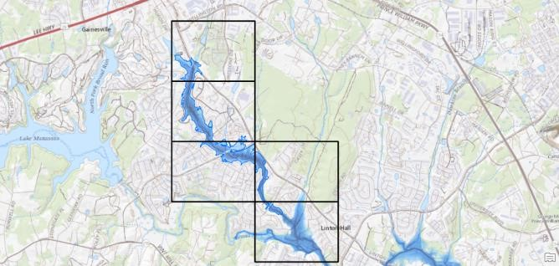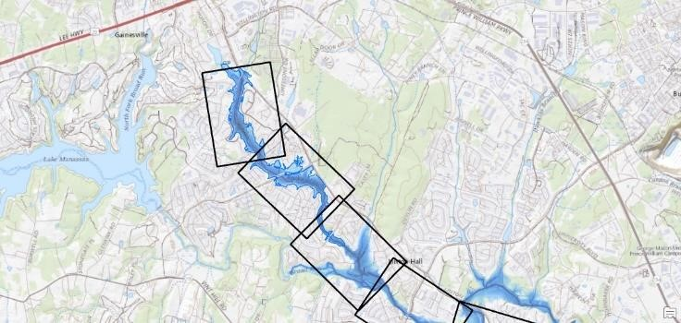

*Figure 5. Left is the "grid index" right is the "strip index"*

## Panel Locator

A panel locator is created as an inset map with simplified symbology showing the location of each sheet

## Legend Overview

Other components of the map include bridges, impacted roads, impacted structures, 5ft to 10ft contour lines (depending on viewability), FEMA SFHAs, the dam point, the inundation study extent and depth raster. The depth raster legend labels is automatically updated to reflect correct values.

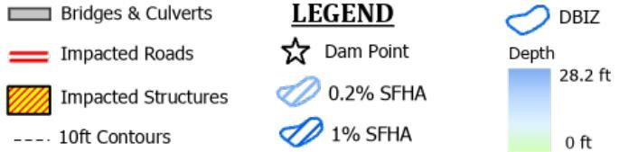

## Call Outs

Callouts are set up to intelligently prioritize based on “variable weights” and display dynamically employing methods such as splitting structures into classes where primary residence structures will receive emphasis and priority (e.g. weight) over secondary structures. If there are too many structures to fit callouts then the map scale can be increased to cover a smaller area in more detail, or callouts can be converted to graphics and manually placed to ensure coverage.

Roadway callouts display similarly with roadways above an AADT threshold (e.g. 150) receiving prioritization over roadways with lower AADTs. Additionally tiny road segments under a certain length threshold will not be labeled and likely removed in the review stage.

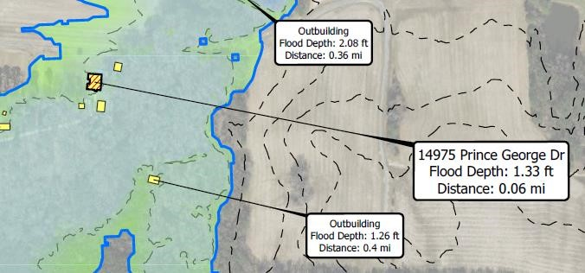

*Figure 6. Mapping cartography showing "variable weight" callouts based on structure class*

# Appendix 3 – Virginia Hazard Classification Data

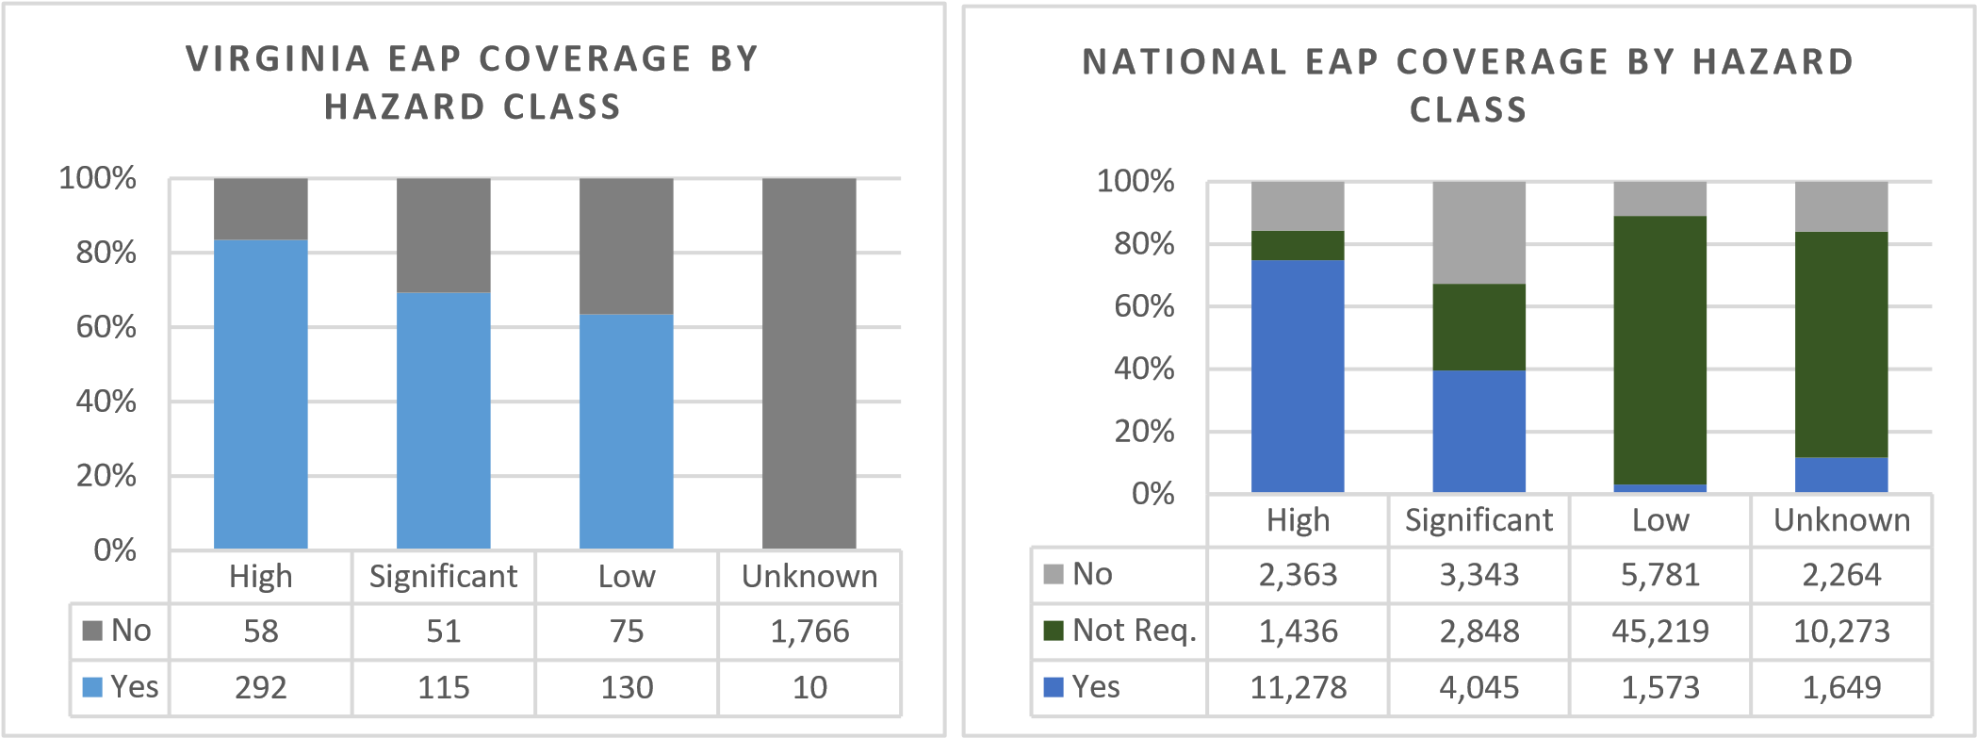

**Virginia Regulated Dams Hazard Class (Top Capac. vs. Top Height)**

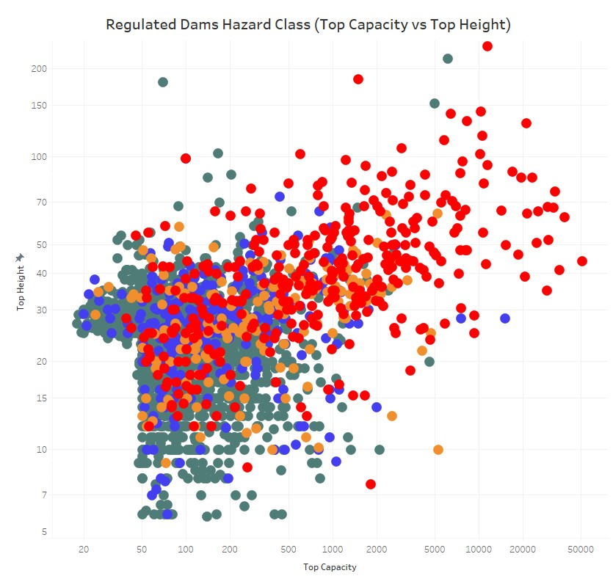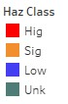

# Appendix 4 – Review of Similar Simplified Methodologies at other National and State Organizations

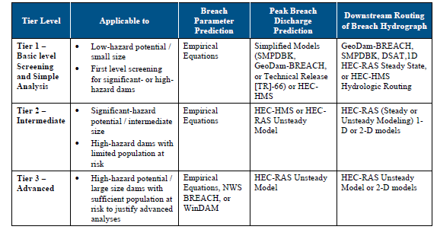

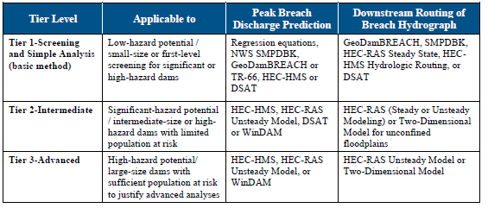

Note: DSAT is a software tool related to DSS-WISE, possible a precursor

(FEMA, 2013)

South Carolina Department of Health and Environment (SDHEC) engaged CDM-Smith to produce simplified inundation maps that appear to have been produced using the HAND algorithm via ArcHydro’s HAND by Flood Depth Table which can allow for their chosen attenuation curve.

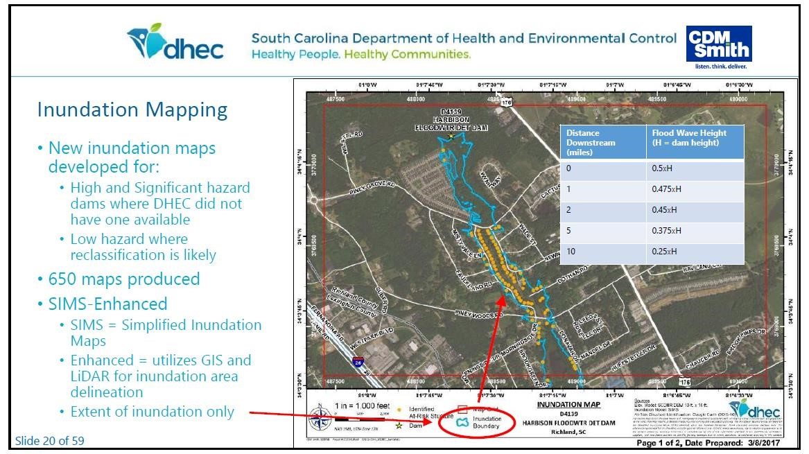

0.00

0.50

1.00

0

5

10

15

20

Miles

Attenuation Curve

h-factor

Documentation for NWS GEOSMPDBK (2011) describes a methodology developed to provide quick guidance to forecasters in critical dam break situations. They are intended to be used as initial estimates before more sophisticated model forecasts are prepared. The routing method was originally derived by plotting observed discharge versus distance downstream on log-log paper for several historical dam failures and visually fitting an approximate curve. Subsequently, a mathematical approximation for that curve was derived. The process was repeated using observed wave height versus downstream distance.

* Maximum flood depth just downstream of the dam is no more than ½ the height of the water behind the dam.
* Flow is reduced by about ½ for each 10 miles of travel downstream of the dam.
* Flood depth is reduced by about ½ for each 10 miles of travel downstream of the dam.

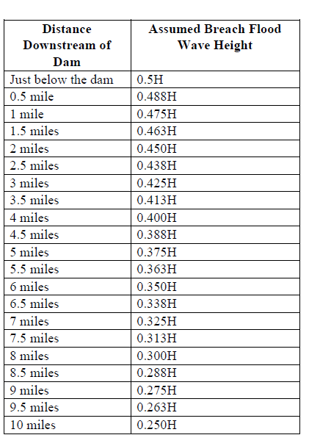Lastly North Carolina SIMS methodology includes the following table in their methodology (NC DEQ, 2017)

## Appendix 5 – Development of more detailed methodologies for estimating PMF and PMF with Break Flows to be tested and incorporated into future simplified modeling enhancements

## PMF Estimation (Dewberry, 2008)

The formula that will be used for estimating PMF is as follows:

$$Q_{p}=\left(\frac{80PMP_{6}^{2}}{0.75PMP_{6}+\frac{600}{CN}-6}+\frac{700PMP_{6}}{CN}\right)\left(A-0.0017A^{2}\right)$$

*Where:*

$$Q_{p}=PMF peak flow resulting from 5-point PMP in cfs$$

$$PMP_{6}=Depth of 6-hr PMP in Inches$$

$$CN=Curve Number (NRCS)$$

$$A=watershed in square miles$$

**PMF Peak Flow Estimation for 28” 6-Hr PMP**

**CN**

This equation was tested against various dam break studies conducted by Dewberry from 2006-2008 and generally predicted PMF peak inflows with less than 1% error compared to the peak PMF inflow obtained from the detailed HMS model (Dewberry 2008).   
  
Further it was tested against DCR HMS models and confirmed to accurately predict results especially when the most commonly used SCS Curve Number Loss and Unit Hydrograph Models are utilized.

**Critical Overtopping Depth**

The table below (FEMA, 1987) shows that a reasonable estimate for Critical Overtopping Depth (Hc) is ~1 ft for a dam in fair condition. This could be added to Water Height (Hw) in the following empirical equations to result in more conservative estimates.

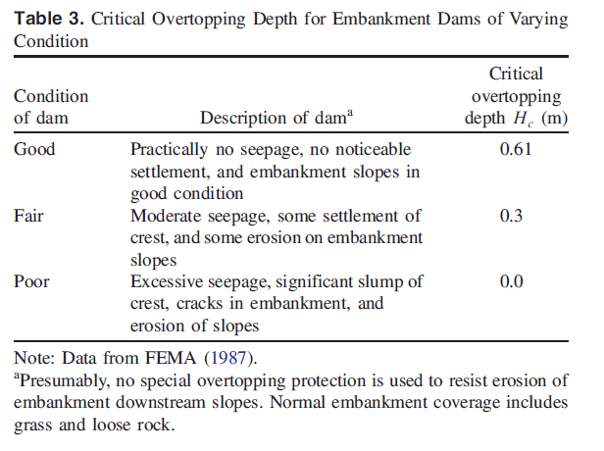

**Failure Time Formula $${\hat{t}}_{f}=63.2×\sqrt{\frac{V_{w}}{gH_{b}^{2}}}$$**

*Where,*

$${\hat{t}}_{f}=Breach formation time (seconds)$$

$$V_{w}=Reservoir Volume at time of failure$$

$$H_{b}=Height of Breach$$

OR

$${\hat{t}}_{f}=60×\sqrt{\frac{V_{w}}{gH_{b}^{2}}}$$

(Froelich, 2016)

## Breach Average Width Formula

$B_{avg}=0.27×k_{M}×V_{w}^{1/3}$,

*Where,*

$$k_{M} is failure mode factor:$$

$$k_{M}=\left\{\begin{matrix}1.3, & \text{ for overtopping failures } \\ 1.0, & \text{ other failure modes }\end{matrix}\right.$$

$m is average breach side­slope ratio \left(h:v\right)$*:*

$$m=\left\{\begin{matrix}1.0, & \text{ for overtopping failures } \\ 0.7, & \text{ other failure modes }\end{matrix}\right.$$

(Froelich, 2008)

OR

$${\overset{ˆ}{B}}_{avg}=0.28×k_{M}×k_{H}×V_{w}^{1/3}×W_{avg}^{-1/6}×H_{b}^{1/6}$$

*Where,*

$W_{avg}$ is average embankment width

$$k_{M}=\left\{\begin{matrix}1.0,\text{ for internal erosion failures } \\ 1.5,\text{ for overtopping failures }\end{matrix},\right.$$

$$k_{H}=\left\{\begin{matrix}{\left(\frac{H_{b}}{20}\right)}^{1/2},\text{ for }H_{b}<20ft, \\ 1.0,\text{ for }H_{b}≥20ft\end{matrix}\right.$$

(Froelich, 2016)

## Peak Discharge Formula

$$Q_{p}=3.1B_{avg}{H_{W}}^{1.5}{\left(γ_{Q}/\left(γ_{Q}+t_{f}\sqrt{H_{W}}\right)\right)}^{3}$$

*Where,*

*Qp = Dam break peak discharge in cfs*

*Bavg = Average breach width in feet*

*Hw = Maximum depth of water stored behind the breach in feet*

*Tf = Breach development time in hours*

*γ = Instantaneous flow reduction factor = 23.4 As/Bavg (equivalent to ‘C’ in Wetmore and Fread (1984))*

*As = Surface area of the reservoir in acres corresponding to Hw*

(NWS SMPDBK equation found in CO DNR 2020)

$${\overset{ˆ}{Q}}_{p}=0.0175×k_{M}×k_{H}×\sqrt{\frac{gV_{w}H_{w}H_{b}^{2}}{W_{avg}}}$$

where $$k_{M}=\left\{\begin{matrix}1; & \text{ for non-overtopping failure modes } \\ 1.85; & \text{ for overtopping failure modes }\end{matrix}\right.$$

$$k_{H}=\left\{\begin{matrix}1; & \text{ for }H_{b}≤20 ft \\ {\left(\frac{H_{b}}{20 ft}\right)}^{0.125}; & \text{ for }H_{b}>20 ft \end{matrix}\right.$$

(2008 Froehlich)



## Works Cited Bibliography

Chow, 1959. Open Channel Hydraulics. McGraw-Hill, New York, NY.

Dewberry, 2018. A simple Equation for Predicting the PMF Peak Flow Generated by the 5-point Distribution PMP

<https://www.dewberry.com/docs/default-source/documents/5point-pmp_equation-asdso-2008.pdf?sfvrsn=326daa7_0>

FEMA, 2010. LiDAR Guidelines FEMA Memo 61

<https://giscenter.isu.edu/pdf/FEMAProcedureMemo61.pdf>

FEMA, 2013. Federal Guidelines for Inundation Mapping of Flood Risks

<https://www.fema.gov/sites/default/files/2020-08/fema_dam-safety_inundation-mapping-flood-risks.pdf>

Froehlich, 2008. Embankment Dams and their Uncertainties

<https://www.researchgate.net/publication/245297448_Embankment_Dam_Breach_Parameters_and_Their_Uncertainties>

Reed & Halgren, NOAA. 2011. Validation of a New GIS Tool to Rapidly Develop Simplified Dam Break Models

[https://www.weather.gov/media/owp/oh/hrl/docs/Validation_of_GeoSMPDBK_2011_07_22_submit_r2](https://www.weather.gov/media/owp/oh/hrl/docs/Validation_of_GeoSMPDBK_2011_07_22_submit_r2.pdf).[pdf](https://www.weather.gov/media/owp/oh/hrl/docs/Validation_of_GeoSMPDBK_2011_07_22_submit_r2.pdf)

Scriven [et al. 2021. GIS derived synthetic rating curves and HAND mo](https://giscenter.isu.edu/pdf/FEMAProcedureMemo61.pdf)del to support on the fly flood mapping

[https://www.researchgate.net/publication/353303940_GIS_derived_synthetic_rating_curves_a nd_HAND_model_to_support_on-the-fly_flood_mapping](https://www.researchgate.net/publication/353303940_GIS_derived_synthetic_rating_curves_a%20nd_HAND_model_to_support_on-the-fly_flood_mapping%20)

US Army Corps of Engineers HEC. 2021. Creating Land Cover, Manning’s N Values, and % Impervious Layers

<https://www.hec.usace.army.mil/confluence/rasdocs/r2dum/latest/developing-a-terrain-model-and-geospatial-layers/creating-land-cover-mannings-n-values-and-impervious-layers>

Wetmore & Fread, 1991. NWS Simplified Dam Break Model

<https://www.hsdl.org/?view&did=8227>

Zheng & Tarboton et al. 2018. River Channel Geometry and Rating Curve Estimation Using Height above the Nearest Drainage

<https://onlinelibrary.wiley.com/doi/abs/10.1111/1752-1688.12661>

## Other Refences

USGS 2013, A GIS tool for cost-effective delineation of flood-prone areas

https://www.sciencedirect.com/science/article/pii/S0198971517303794

MD 20[18, Guidance for Completing a Dam Breach Analysis for Small Ponds in Maryland](https://www.fema.gov/sites/default/files/2020-08/fema_dam-safety_inundation-mapping-flood-risks.pdf)

[https://mde.ma](https://www.fema.gov/sites/default/files/2020-08/fema_dam-safety_inundation-mapping-flood-risks.pdf)ryland.gov/programs/Water/DamSafety/Documents/Dam-BreachAnalysis/2018-05-15-Breach-Analysis-Guidance.pdf

NC DEQ 2017, North Carolina Simplified Inundation Maps (SIMs) for Emergency Action Plans (EAPs)

<https://files.nc.gov/ncdeq/Energy%20Mineral%20and%20Land%20Resources/Land%20Quality/Dam%20Safety/North%20Carolina%20SIMS%20Methodology_Rev%20April%202017.pdf>

Scriven [et al. 2021, GIS derived synthetic rating curves and HAND mo](https://giscenter.isu.edu/pdf/FEMAProcedureMemo61.pdf)del to support on the fly flood mapping

[https://www.researchgate.net/publication/353303940_GIS_derived_synt](https://www.sciencedirect.com/science/article/pii/S0198971517303794)hetic_rating_curves_a [nd_HAND_model_to_support_on-the-fly_flood_mapping](https://www.sciencedirect.com/science/article/pii/S0198971517303794)

Garousi-Nejad & Tarbaton et al. 2019, Terrain Analysis Enhancements to the Height Above Nearest

Draina[ge Flood Inundation Mapping Method https://agupubs.onlinelibrary.wiley.com/doi/full/10](https://mde.maryland.gov/programs/Water/DamSafety/Documents/Dam-Breach-Analysis/2018-05-15-Breach-Analysis-Guidance.pdf).1029/2019WR024837

Zheng & Tarboton et al. 2018. River Channel Geometry and Rating Curve Estimation Using Height above the Nearest Drainage

[https://onlinelibrary.wiley.com/doi/abs/10.1111/1752-16](https://www.researchgate.net/publication/353303940_GIS_derived_synthetic_rating_curves_and_HAND_model_to_support_on-the-fly_flood_mapping)88.12661

Nobre et al. 2015. HAND contour: a new proxy predictor of inundation extent https://onlinelibrary.wiley.com/doi/abs/10.1002/hyp.10581

DCR, 2018. Dam Break Inundation Zone Modeling and Mapping Procedures

<https://www.dcr.virginia.gov/form/dcr-vswcb-038.pdf>

Oak Ridge Labs, 2020. Continental Flood Inundation Mapping

<https://cfim.ornl.gov/data/>

Chow, Ven Te. 1959. Open Channel Hydraulics. McGraw-Hill, New York, NY.

Froehlich, 2008

Froelich, 2016

Zomorodi / Dewberry, 2018. A simple Equation for Predicting the PMF Peak Flow Generated by the 5-point Distribution PMP

<https://www.dewberry.com/docs/default-source/documents/5point-pmp_equation-asdso-2008.pdf?sfvrsn=326daa7_0>

CO DNR, 2020. Guideline for Dam Breach Analysis.

<https://dnrweblink.state.co.us/dwr/ElectronicFile.aspx?docid=3566962&dbid=0>